RESDING CANDLESTICK CHARTS:

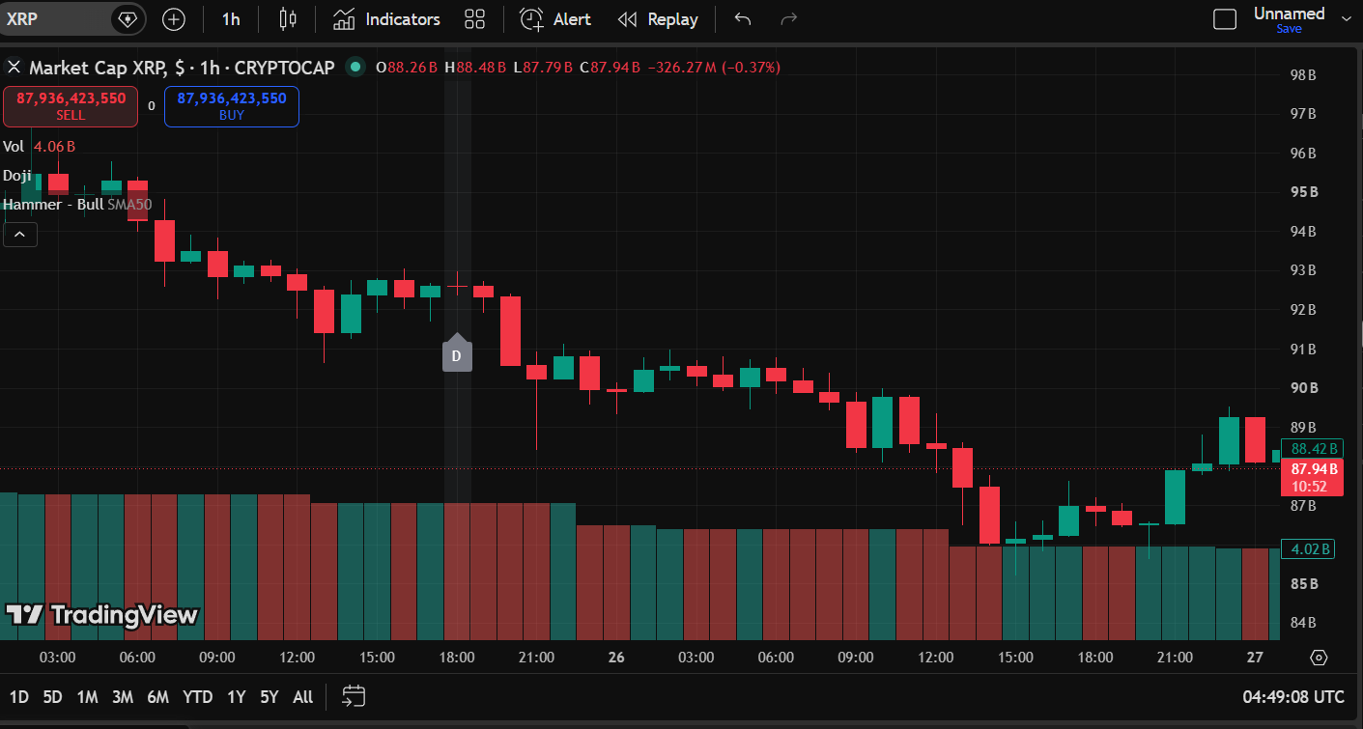

CANDLESTICK OBSERVACTION REPORT:

Particulars | Details
Asset Name | XRP
Symbol | XRPUSD
Time Frame | 1 Hour
Number of Green Candles Observed | 9
Number of Red Candles Observed | 11
Doji Observed | 1Observed
Hammer Observed | Not Observed
Shooting Star Observerd | Not Observed

OBSERVING PRICE DIRECTION:

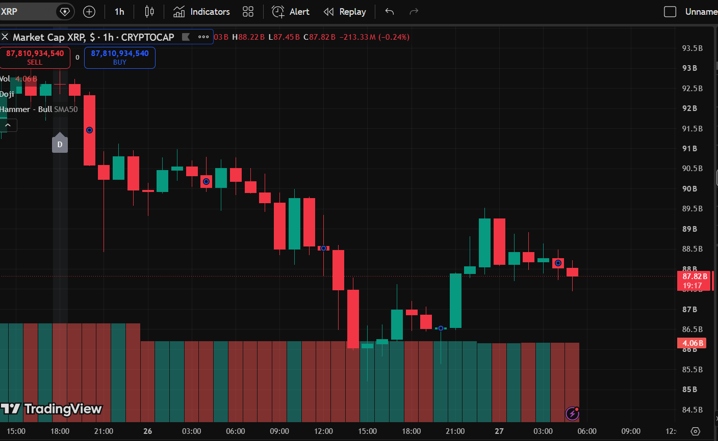

TREND OBSERVATION REPORT:

PARTICULARS | DEATILS
Asset Name | XRP
Symbol | XRPUSD
Time Frame | 1Hour
Number of Candlesticks | 40
Reason For Identifying the Trend | The Chart Shows a Series of Lower High and Lows,Indicating an Downtrend

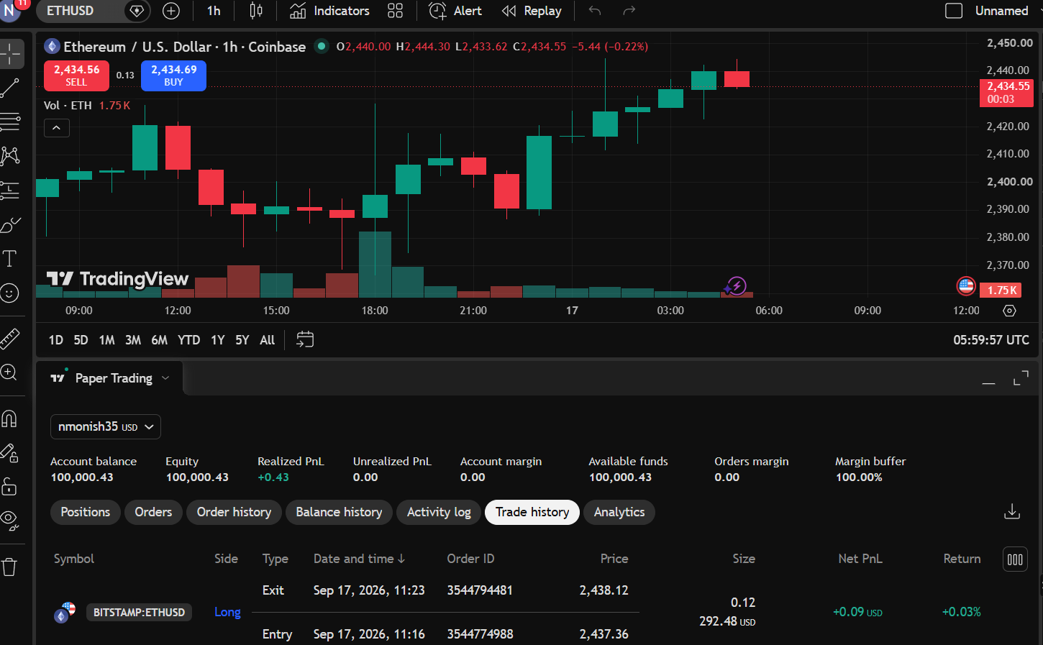
Trend-Based Trade Report.

Particular | Observation
Asset Name | ETHEREUM
Symbol | ETHUSD
Timeframe | 1 Hour (1H)
Trend Observed | UpTrend
Trade Type | Long (buy)
Entry Price | 2,437.36
Exit Price | 2,438.12
Realized Profit/Loss | 0.09
Trade Outcome | Profit
Reason for Identifying the Trend | The chart shows a series of lower highs and lower lows , indicating an Up Trend.

